# Required Programs:

## QUIT:

QUIT is used to generate your T1, T2, and Myelin Water Fraction (MWF) maps

Download link: <https://github.com/spinicist/QUIT/releases>

1. Use the command to unzip file

**tar -xzf qi-linux.tar.gz**

1. After extracting, you should see a file called “qi “. Move this file to the following location

**/usr/local/bin**

1. To test if successfully installed type the following in the terminal

**qi despot1 --help**

You will get the following output:

*NOTE: If prompted to install missing libraries, follow the onscreen commands to install them.*

## FSL:

FSL is used to skull-strip, generate masks, carry out calculations, etc.

Download link: <https://fsl.fmrib.ox.ac.uk/fsldownloads_registration>

FSL uses an installer script simply open a terminal in the folder containing the script and type: **python fslinstalller.py** or **python3 fslinstaller.py**

If python is not installed used the following commands to install python first:

**sudo apt-get update**

**sudo apt-get install python3.6**

The following commands test to see if FSL is installed correctly

**echo $FSLDIR**

This will display the name of the directory FSL is install in

**flirt -version**

This will display the version of FSL

**fsl**

Will open the FSL GUI which looks like this:

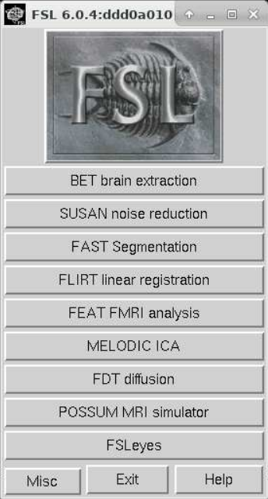

## Dcm2nii:

Used to convert raw dicoms to a compressed nii.gz format (commonly used in quantitative programs)

Type the following command into the terminal:

**sudo apt install dcm2nii**

**sudo apt install dcm2niix**

The second command is for the compressed option

# Pipeline commands

A patient folder will contain the following files:

**DESPOT1.nii.gz** – Raw despot1 dicoms

**DESPOT2_P0.nii.gz** – Raw despot2 phase 0 dicoms

**DESPOT2_P180.nii.gz** – Raw despot2 phase 180 dicoms

**B1Map_Scan.nii.gz** – B1 map dicoms

**SPGR** – Text file containing despot1 flip angles

**SSFP** – Text file containing despot2 flip angles

**INPUT** – Text file containing both despot1 and despot2 flip angles

**MPRAGE.nii.gz** – MPRAGE dicoms

fslsplit DESPOT1.nii.gz

*splits the despot1 file into 8 separate volumes labeled DESPOT1_volume0.nii.gz, DESPOT1_volume1.nii.gz……..DESPOT1_volume7.nii.gz

Fslmaths B1Map_Scan.nii.gz -div 800 B1Map_Before

*Divides all voxels by a value of 800 and creates a new file called B1Map_Before.nii.gz

bet DESPOT1_Volume1.nii.gz DESPOT1_Volume1_brain.nii.gz -R -m

*Skull strips volume 1 of the despot sequence generate a mask file called DESPOT1_Volume1_brain_mask.nii.gz which will be renamed to Mask.nii.gz moving forward.

Resample B1MAP_BEFORE.nii.gz & MPRAGE.nii.gz using DESPOT1_Volume1.nii.gz as the reference in 3DSlicer. Name them B1Map.nii.gz and MPRAGE_resampled.nii.gz accordingly.

qi despot1 DESPOT1.nii.gz --mask=Mask.nii.gz --B1=B1Map.nii.gz < spgr –algo=n

*Command to generate T1 maps. Rename D1_T1.nii.gz to T1_Map.nii.gz

fslmerge -t DESPOT2 DESPOT2_P180.nii.gz DESPOT2_P0.nii.gz*

*Combines both phases of despot2 into one file called DESPOT2.nii.gz

qi despot2fm T1_Map.nii.gz DESPOT2.nii.gz –mask=Mask.nii.gz --B1=B1Map.nii.gz <ssfp

*Command to generate T2 maps. Rename FM_T2.nii.gz to T2_Map.nii.gz

qi mcdespot DESPOT1.nii.gz DESPOT2.nii.gz --mask=Mask.nii.gz --B1=B1Map.nii.gz --f0=FM_f0.nii.gz --scale --algo=G --tesla=3 --its=4 --model=3 < input

*Command to generate MWF maps. Rename 3C_f_m.nii.gz to MWF_Map.nii.gz

# GUI Guide:

**Note: Make sure to not change file names, the program is name specific

**Step 1:** Create a folder for the patient containing the raw DICOM folders + the flip angle files (input, spgr, ssfp)

**Step 2:** Open a terminal in the folder containing the MWF.py script and type: **python3 MWF.py**

**Step 3:** The GUI looks like the image below. Use the browse button to set the directory of the patient you wish to analyze. Make sure to check the three boxes (B1 Map, Mask, MPRAGE).

**Step 4:** Press the buttons in order from left to right. The first button ‘Convert DICOM’ will convert all the raw DICOMS to NIFT (a compressed format). Each button will print a message in the terminal when it is complete. For example, ‘Convert DICOM’ will print **“DICOMS converted to NIFTI”** when finished

After the command is done, your patient folder should look like this.

**Step 5:** The Generate mask button will create Mask.nii.gz and the files you need to resample the B1Map and MPRAGE to DESPOT space; DESPOT1_Volume1.nii.gz

**Step 6:** Before moving on with the GUI, you will need to use 3DSlicer to resample. Open up 3DSlicer, drag and drop the three files into 3DSlicer: B1Map_Before, DESPOT1_Volume1, and MPRAGE.

**Step 7:** In the module drop list choose Registration> Resample image (BRAINS). In the ‘Image to Wrap’ Choose either B1Map_Before or MPRAGE. In the Reference Image choose DESPOT1_Volume1

For the Output, choose to save as and name them B1Map (For the resampled B1) and MPRAGE_resample (For the resampled MPRAGE)

Make sure to press the save button in the top left corner after and save them to your patient folder in the NifTI(.nii.gz) file format.

**Step 8:** After you’ve resampled the images and placed them into the patient folder. Press the ‘Initialization” Button to organize all the files.

**Step 9:** Now you can go through each button one at a time in order. T1 Map > T2 Map > MWF Map > Statistics.

If you want to look at the statistics again or for a patient with data already analyzed, use the **‘Reprint Statistics’** button.

‘Lobes Seg’ is used for lobe parcellation which requires the Freesurfer files.